| **Art Schedule** | | | | | |
| --- | --- | --- | --- | --- | --- |
|  | **Monday** | **Tuesday** | **Wednesday** | **Thursday** | **Friday** |
| **7:45-8:30**  **5th Grade** | Wall | Thompson |  | Queen | Wall |
| **12:15-1:00**  **Third Grade** | Gammon | Reinaldo | White | Farrington | Gammon |
| **1:15-2:00**  **Fourth Grade** | Martin | Posey | Poston |  | Martin |

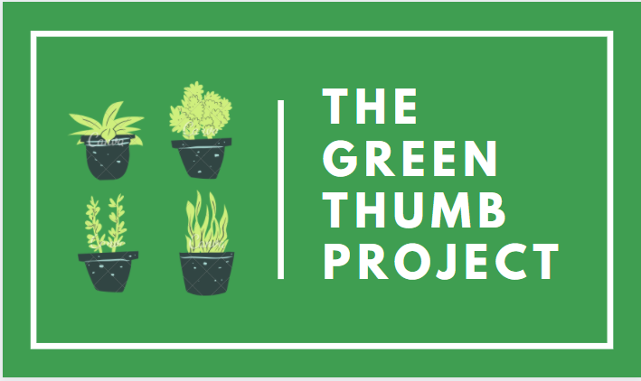

| **TGTP Weekly Lessons** | | | |
| --- | --- | --- | --- |
| Date | Focus | Supplies Needed | Links needed |
| Session 1 | Grant & Kit Introduction | * Computer/iPad * Pencil * TGTP Workbook | * [Session 1 video-link](https://drive.google.com/file/d/1sPakEjO-gKhVGqVe7D5XopTigThmDRvQ/view?usp=sharing) * [Initial student survey](https://forms.office.com/Pages/ResponsePage.aspx?id=H_vimqLeQ0yBlHYk_LuzDD1VqZJGLC5GtqmuJYH-wS5UMEFBN1BITEhETkhNRUo2VllHRUxESk45RS4u) |
| Session 2 | color wheel/mixing colors, thumb and plant art examples, flower pot design draft | * Pencil * TGTP Workbook * Crayons/colored pencils | * [Session 2 video-link](https://drive.google.com/file/d/173-FWI2OF8FLzAL5ot2v5IGhF1Su16hm/view?usp=sharing) |
| Session 3 | Students will paint flower pot | * Flower pot * paint * Pencil * TGTP Workbook | **No Video** |
| Session 4 | Students will plant flower and begin online GTP Story Book | * Flower pot * Seeds * soil * Pencil * TGTP Workbook | * [Session 4 video -link](https://drive.google.com/file/d/1ILy8ZtybVQ5Kwle1XIECsyZu0EvueCSG/view?usp=sharing) |
| Session 5 | Students will use their daily reflections to write their online story book | * Computer * TGTP Workbook | * [Session 5 video-link](https://drive.google.com/file/d/1fjnh4rY3Fdc6Z0Ib2csFMLhn5qaphaAh/view?usp=sharing) * [Storybook website tutorial video](https://drive.google.com/file/d/1cAlRtwpc2yFyIfkfd8Z0Pyert41MHYUB/view?usp=sharing)-Ms. Scott * [StorybookYoutube tutorial video](https://youtu.be/QlqrpmFL55E) * [Final student survey](https://forms.office.com/Pages/ResponsePage.aspx?id=H_vimqLeQ0yBlHYk_LuzDD1VqZJGLC5GtqmuJYH-wS5URVFZMzUyQUpaRUlQR0NEMUswVTdOWlU4VS4u) |